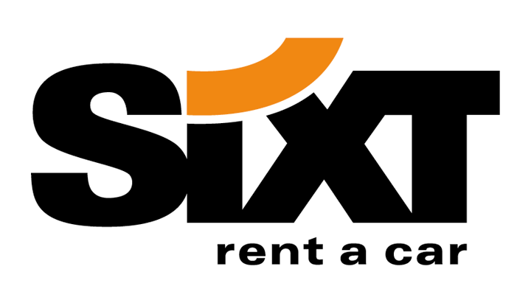
Voucher Order Form

Send to: Sixt Travel Agency Department
Mrs. Kathryn Burkhart
Munich - Germany

Fax: 0049-89-7 44 44 8 – 4119

E-mail: kathryn.burkhart@sixt.de

(Please fill-in in block letters. This is all mandatory information!)

Travel Agent details:
Travel Agency Name:
Travel Agency No. (issued by Sixt)
Contact Person:
Street:
Postal-Code / City
Telephone / Fax:
E-mail:
IATA- or TIDS-number:
(If applicable)

National Sixt HQ details:
Country: | Czech Republic
Contact Person: | Pavel Soukup
Position: | District Sales Manager
Telephone / Fax: | +420 266 007 054 / +420 266 007 013
E-mail: | pavel.soukup@sixt.cz

Voucher Order:
Number of Vouchers:

The Sixt Travel Agency Department is only responsible for issuing vouchers to the ordering countries. Billing of the vouchers is done through individual invoices by the respective National Sixt HQ of the country ordering the vouchers. The National Sixt HQ of the ordering country has its own responsibility in verifying the credibility of the Travel Agent and invoicing issued vouchers. I/We confirm the correctness of the content in this application

Agency-Number:  → xx xx xx | Country:  → Iso-Code
Voucher Amount:
→ xx xx

→ do not write in this field!

Signature Place and Date

Sixt GmbH & Co Autovermietung KG, Sales Department, Zugspitzstrasse 1, 82049 Pullach, Germany

